*# Create a config file for a 3 nodes cluster*

cat << EOF > kind-3nodes.yaml

kind: Cluster

apiVersion: kind.x-k8s.io/v1alpha4

nodes:

- role: control-plane

- role: worker

- role: worker

EOF

*# Create a new cluster with the config file*

kind create cluster --name wslkindmultinodes --config ./kind-3nodes.yaml

*# Check how many nodes it created*

kubectl get nodes

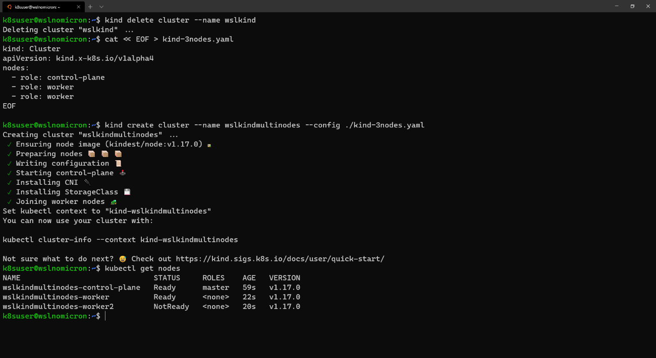

*# Check the services for the whole cluster*

kubectl get all --all-namespaces

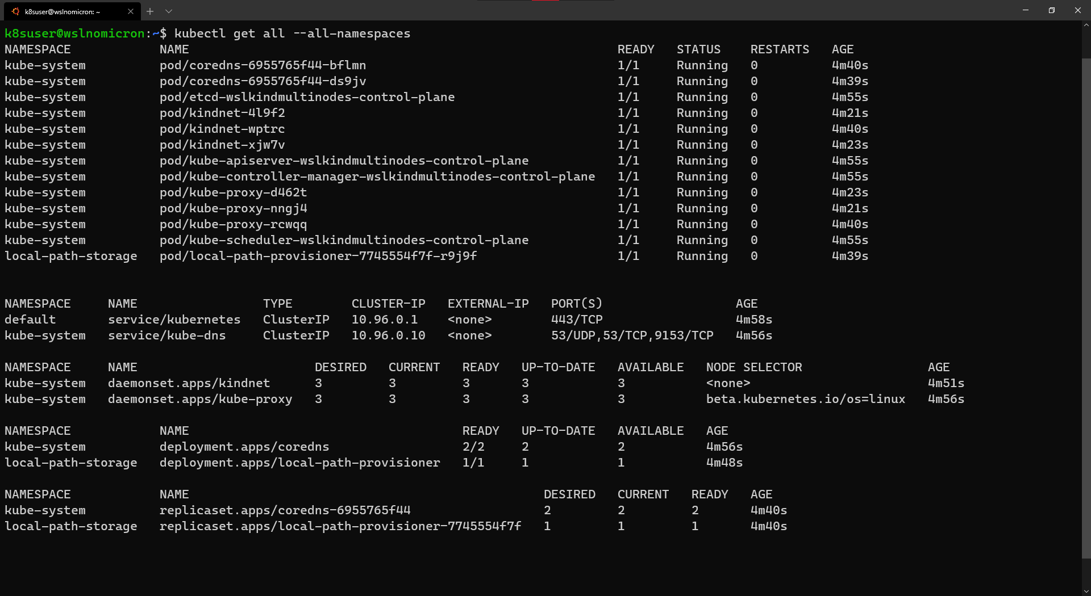

*# Install the Dashboard application into our cluster*

kubectl apply -f <https://raw.githubusercontent.com/kubernetes/dashboard/v2.0.0-rc6/aio/deploy/recommended.yaml>

*# Check the resources it created based on the new namespace created*

kubectl get all -n kubernetes-dashboard

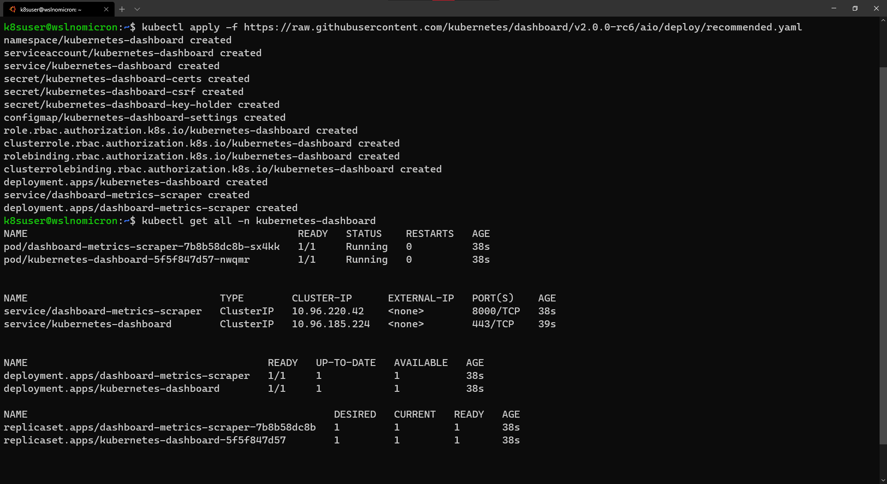

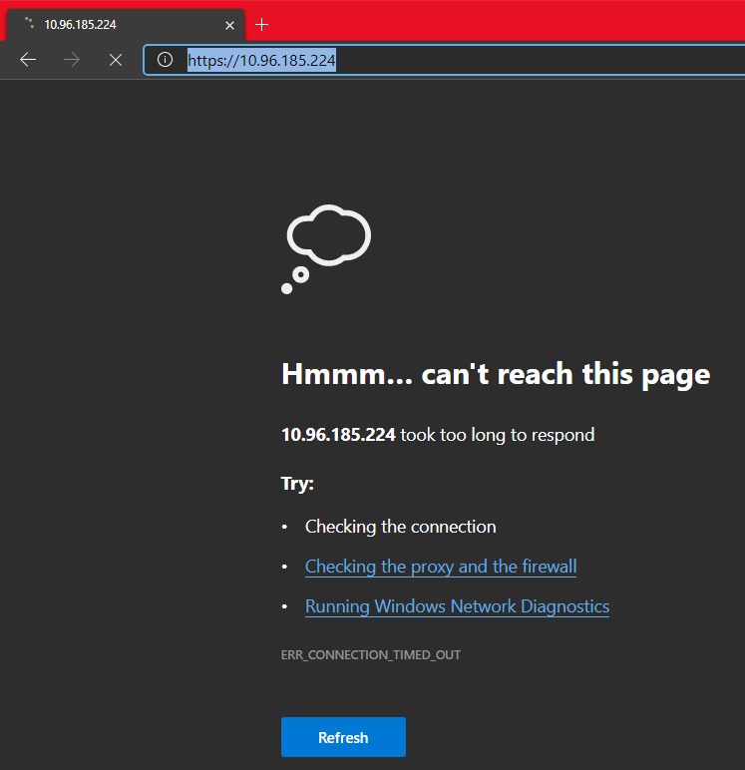

*# Start a kubectl proxy*

kubectl proxy

*# Enter the URL on your browser: http://localhost:8001/api/v1/namespaces/kubernetes-dashboard/services/https:kubernetes-dashboard:/proxy/*

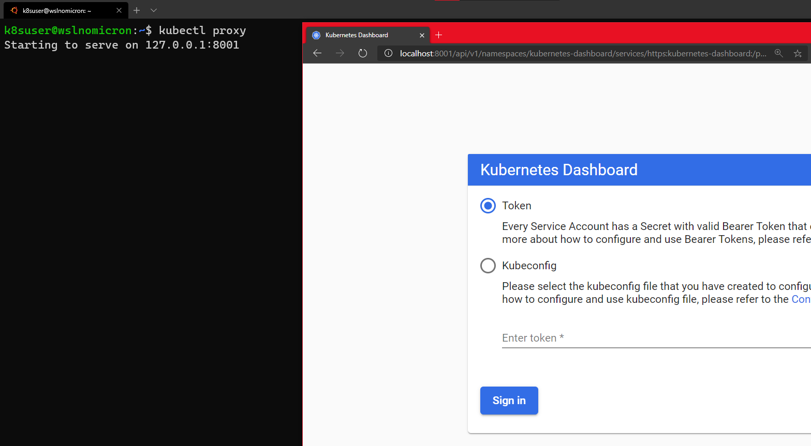

*# Create a new ServiceAccount*

kubectl apply -f - <<EOF

apiVersion: v1

kind: ServiceAccount

metadata:

name: admin-user

namespace: kubernetes-dashboard

EOF

*# Create a ClusterRoleBinding for the ServiceAccount*

kubectl apply -f - <<EOF

apiVersion: rbac.authorization.k8s.io/v1

kind: ClusterRoleBinding

metadata:

name: admin-user

roleRef:

apiGroup: rbac.authorization.k8s.io

kind: ClusterRole

name: cluster-admin

subjects:

- kind: ServiceAccount

name: admin-user

namespace: kubernetes-dashboard

EOF

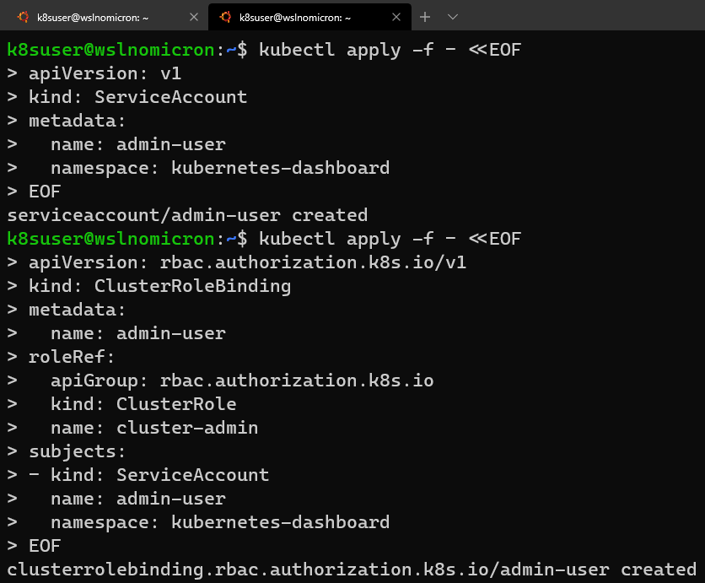

*# Get the Token for the ServiceAccount*

kubectl -n kubernetes-dashboard describe secret **$(**kubectl -n kubernetes-dashboard get secret | grep admin-user | awk '{print $1}'**)**

*# Copy the token and copy it into the Dashboard login and press "Sign in"*

